FEATURES IN WORD

READING LAYOUT VIEW
This feature is available in Office XP versions only. How often do you print long documents just because it's easier to read them on paper than it is on the screen? If this sounds familiar, then the new reading layout view could be ideal for you. Reading layout view is especially designed to make reading on the screen easier and more pleasant. Just imagine all the time you'll save if you don't have to wait for the printer—to say nothing of all the wasted paper.

Where to find it in word.

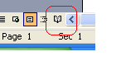
LIMITATION:
Reading layout view creates an easy on–screen reading experience. Without changing the document itself, it alters the layout of the page and improves font display to make text easier to read. Reading layout is all about reading documents You will find that with this feature you can read documents on the screen that previously you would have printed out. It isn't designed for writing. Although you can do small edits, if you want to make extensive changes to a document, you will be better off using another view, such as print layout. It isn't an accurate representation of what the document will look like when printed—that's what print preview is for. It isn't the best way of viewing text boxes, graphics, or tables; it's ideal for long textual documents.

COMPARE DOCUMENTS
Compare side by side– available with Office XP versions. Handy tool for comparing documents. Better way—reviewing

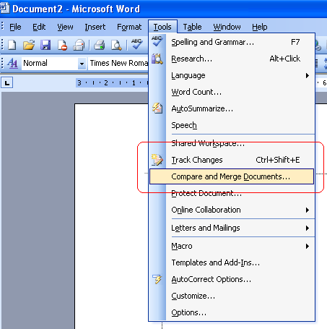

This feature can be used when reviewing and comparing two documents (more so when you have forgotten to switch on the track changes mode before sending it to the client. All you need to do is to open the original document, activate the compare feature and then open the modified document, you will find that all changes (insertions, deletions, format changes etc) highlighted with no effort on your part.

RULER & TABS
Many people ignore it and use the various dialog boxes instead But once you know how to use it, you'll wonder how you ever coped without it. Due to ignorance its functionality is rarely used. You can quickly set up margins, tab stops, and hanging indents The bar across the top of your Word document with measurements marked out on it.
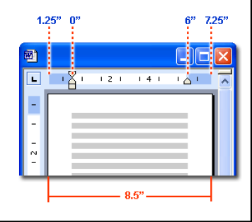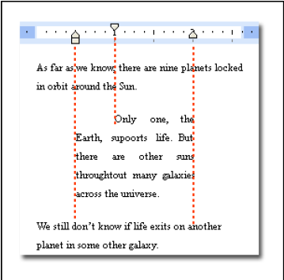

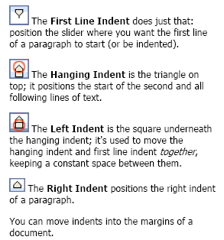

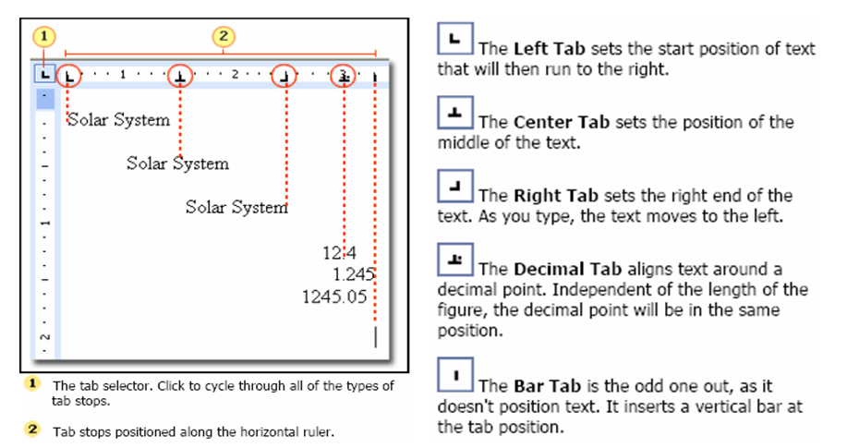

FEATURES IN MICROSOFT POWER POINT (2000 AND XP VERIONS)

Printer’s dilemma
For those of you who use MS Power point to make you presentations may have faced this dilemma many a times. Your online presentation is full of colour, graphics and other decorations but when it comes to giving printed hand outs it can be a very expensive proposition.

Where to find them: [FILE→PRINT →COLOR/ GRAY SCALE]

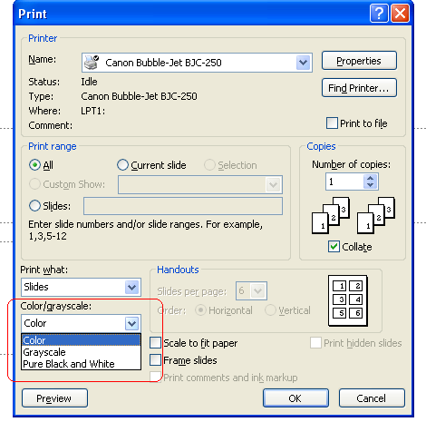
Most presentations are designed to be shown in color, but slides and handouts are usually printed in black and white or shades of gray (grayscale). When you choose to print, Microsoft PowerPoint sets the colors in your presentation to match your selected printer's capabilities. For example, if your selected printer is black and white, your presentation will automatically be set to print in grayscale.
With print preview, you can see how your slides, notes, and handouts will look in pure black and white or in grayscale, and adjust the look of objects before you print.
You can also make certain changes when you preview before printing. You can select:
- What you want to print: the presentation, handouts, notes pages, or just the outline.
- A layout for handouts.
- To add a frame around each slide for print out only.
- Orientation (portrait or landscape) for handouts, notes pages, or an outline.
- Header and footer options.
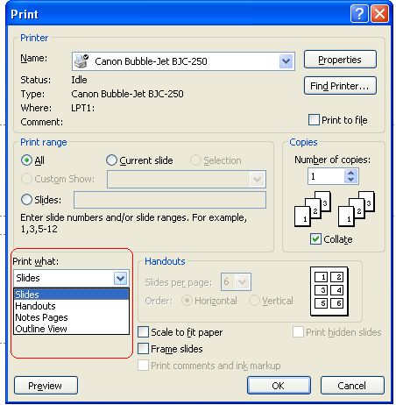

Pack & Go
Often when you transfer your presentation on to another PC there is every likely chance that the PC may not support some of the fonts/ formatting or you ma forget to transfer a linked file. It could spell disaster for you.

Where to find them: [FILE→PACK AND GO]

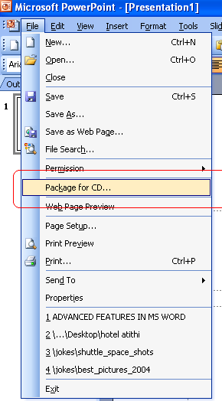
When you want to run a presentation on another computer, use the Pack and Go Wizard to put all the required files into one file and copy the file to a disk or network location. You then unpackage the file onto the destination computer or network and run the presentation.
When you package your presentation, you can include any linked files in the package, and if you use TrueType fonts you can embed them as well. Embedding fonts guarantees that the fonts will be available when you run the presentation on a different computer. (However, note that the wizard cannot include TrueType fonts that have built-in copyright restrictions.)
If you make changes to your presentation after you package it, just run the Pack and Go Wizard again to repackage it. You can package multiple presentations at once.

Including the PowerPoint Viewer
When you use the Pack and Go Wizard, you have the option of including the Microsoft PowerPoint Viewer in the package. Include the viewer if you will be running the presentation on a computer that doesn't have Microsoft PowerPoint installed. The viewer enables you to run the presentation in PowerPoint format.
To package the viewer, you must first have it installed on your computer. You can install it by using a link from the Pack and Go Wizard, after which you can package it with your presentation. If you just want to install the viewer, you can do so directly from the Microsoft Office Web site.
The viewer is not available in the Pack and Go Wizard if you're packaging password-protected presentations; these cannot be run using the viewer
These are some of the tools for a smarter use of technology to ones advantage, which hopefully will help prevent our hard work going down the drain all because of a few glitches.

FEATURES IN WINDOWS XP

WINDOWS DISK CLEANER

Where to find it

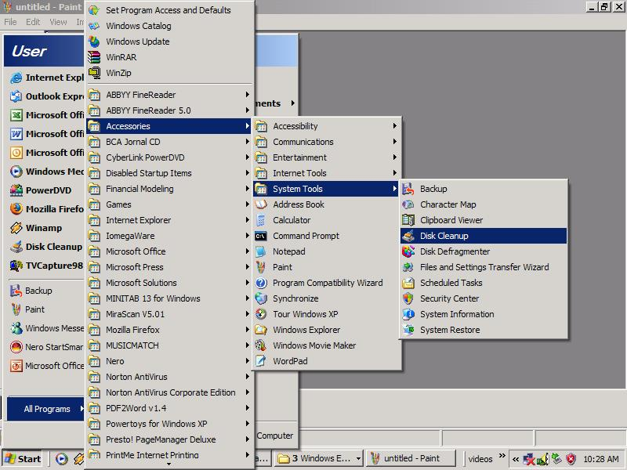

Step 2 Select the drive that you want to the utility to clean

Step 3 Options available -select/ deselect what to clean

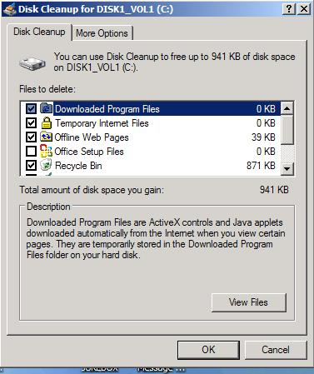

MIGRATING/ TAKING YOUR PERSONALISED SETTINGS TO ANOTHER PC

It is very common for professionals to be working from multiple locations. To put it differently, an average person at the workplace would have a desktop and when working on site (at client locations) either a laptop or maybe a PC at home. A niggling problem faced by such a person would be that he would have to constantly keep updating the setting. Often he would find that some settings done in the office / home have to be done all over again. There are times when you buy a new PC or have to format the old hard disk. Here remembering all the minute and painstakingly configured tweaks and personalized settings may be lost or will have to be done from the scratch. With Windows XP it may be a thing of the past. How??? Windows XP now comes with a built in File setting transfer wizard.

Where to find it
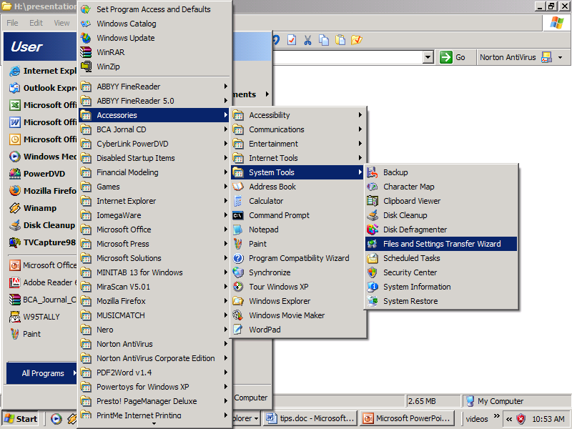

The File & setting transfer wizard comes with a basic set of instructions which can be answered with a few clicks and the rest of the work will be done by the wizard (see pic to learn more)
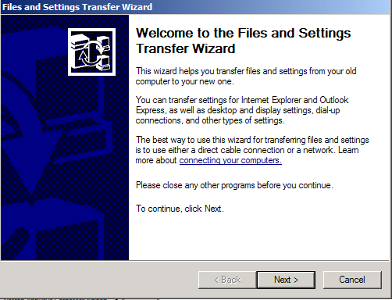

After having backed up your settings you may want to restore the same, this can be achieved by just following the instructions given by the wizard (see pic)

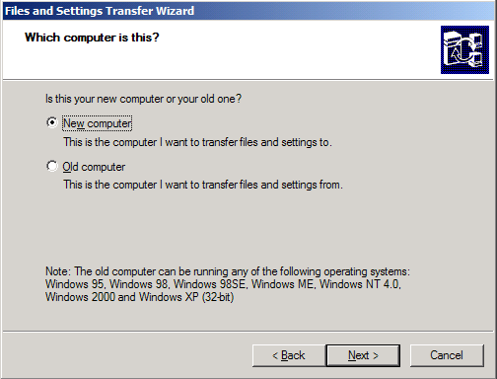

The Files and Settings Transfer Wizard helps you move your data files and personal settings from your old computer to your new one, without having to go through much of the same configuration you did with your old computer. For example, you can take your personal display properties, folder and taskbar options, and Internet browser and e-mail settings from your old computer and place them on the new one. The wizard will also move specific files or entire folders, such as My Documents, My Pictures, and Favorites. Passwords are not moved with program settings when you use the Files and Settings Transfer Wizard. This is a feature of the Files and Settings Transfer Wizard that helps to keep your passwords confidential.

We recommend that you install a virus detection program on the new computer before transferring files over from the old computer. This can help protect your new computer from viruses that may be contained in the files transferred over from your old computer.

TAKING BACKUPS ON CD (R/ RW) USING NERO (VER 6)

Various options are available for taking backups, one of the more preferred option is using a software like Nero. Although the options provided are not unique but one can say that they are convenient. The options can be you have a variety of options for backups or for copying files, add to this you also have the option of having / creating a multi-session disk, which means that you can use the same disk to take multiple backups, what more, after the first session, the software will check if any of the backed up files

This software is usually part of the package when you buy a CD Recorder. The first start up screen looks like the figure below.

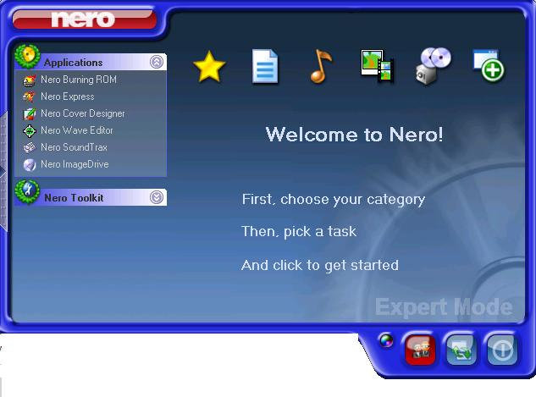

Since we want to back up our files, it is important that we select the right option. So what are the options available to us, see the figure below. First place your mouse pointer on Favorites and the most commonly used options (not all the options) will be displayed. One can make a data CD or make an audio CD (which would be compatible with any audio CD player), one could also make a VCD or simply copy any disc. In order to activate the wizard associated with the relevant option, all you have to do is select and click and then just follow the instructions on the screen. (data back example has been explained below)

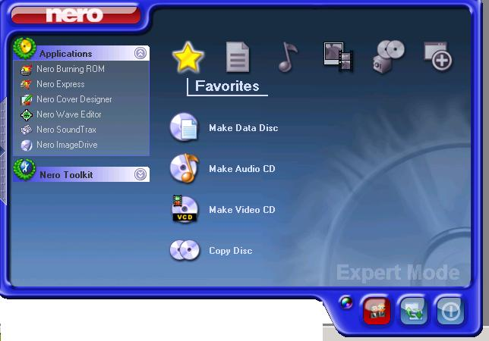

In order to see all the options for our immediate purpose, click on the second icon (as indicated in the picture below). Place the mouse pointer on the icon and the options available for the data backup will be displayed on the screen. The only difference between this option of data disc and the other options (back up Hard drive) is that the data disc option lets you decide which files are to be backed up or copied on to the disc, where are the hard drive back up will simply back up the drive chosen by you.

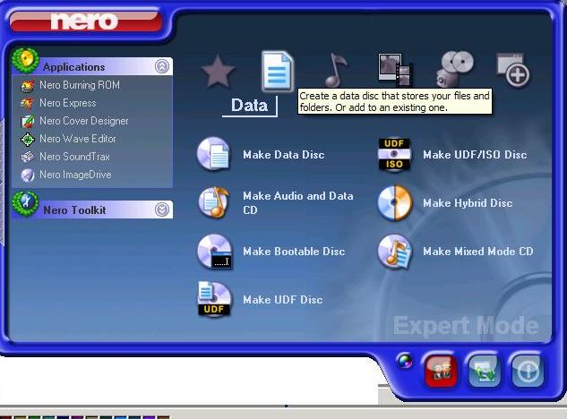

On selecting the data disc option the screen will activate the wizard, all you have to do is click. Some of the common options have been highlighted. It is important to note that each CDR (not only CDRW) can be used more than once. For that you need to click on the option “Start Multi-session disc”, if you prefer that nothing more should be recorded then select “No Multi-session”. The advantage of a Multi session disc is that the next time when you insert the disc and activate Nero, it will ask you to refresh and thereafter search through your hard drive and compare the same to the data on your disc to identify those files which have been modified since your last back up so that only the modified files will be updated. Here 2 points must be clearly understood
- It will update only those files which have been modified, other files will remain untouched
- Even if you have deleted some files from the Hard drive, then the files on you CD will remain as a part of the record, they will remain unaffected in the subsequent sessions.

Although this feature gives you the convenience of a smart & efficient backup system, it would still be prudent to have a policy about data redundancy and data validation, because some day in future when you try to restore the back up you find that either the data is redundant or corrupted as a result you may end up in a worse position.

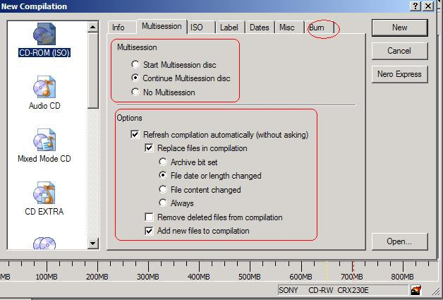

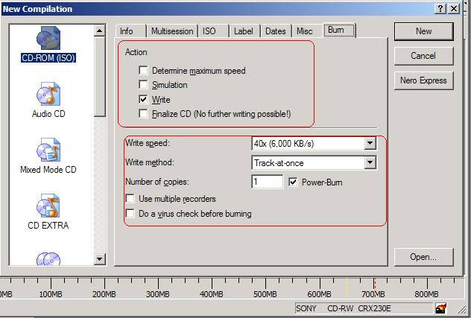

Another option available to back up the entire hard drive, select the option as shown in the figure below

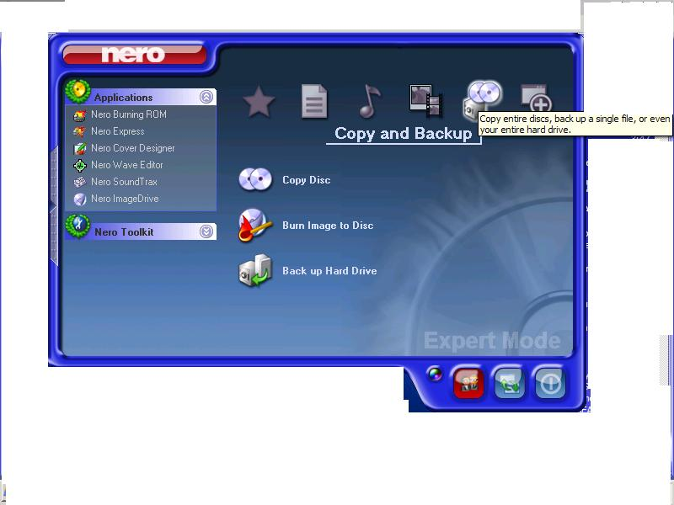

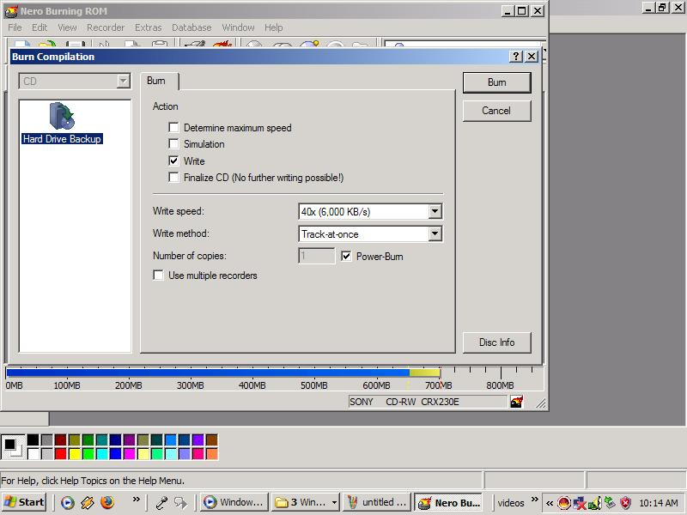

WINDOWS POWER TWEAKS

Although most of us would be satisfied with the plain vanilla Windows 98/ XP, where as some others may want more. For all those who want more can read further.

The software operating system / application that is installed on a PC would have only default settings that is to say they would be common or minimum settings, an advanced or a power user may want more. The Windows operating system and other Microsoft applications come with various options which can help the user to customize the same. Some examples of have been considered below.

** please note that all the options described below require a certain level of expertise and good working knowledge of the operating system/ application. It would be advisable to use these options under the supervision of your support service provider

MSCONFIG
In this mode you can customize, among other things, what items will be loaded at the start up. A universal complaint is that the boot up process is very slow, it takes the PC forever to start. There could be various reasons like, low RAM, low HDD, even TOO MANY START UP FILES.

See picture for activation process

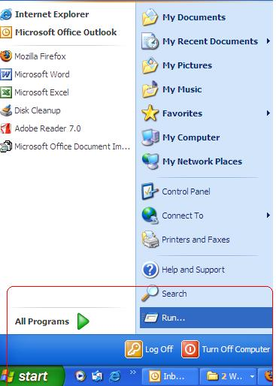

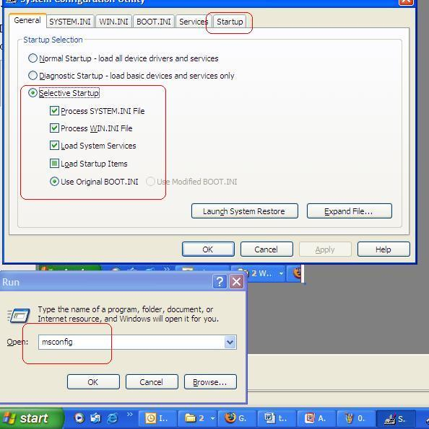

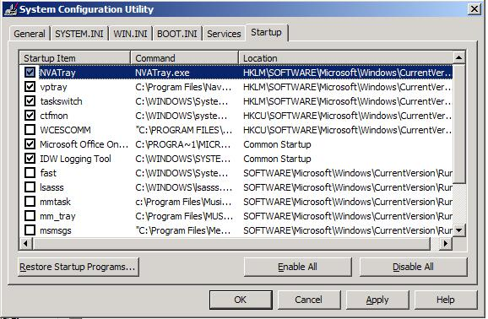

All you need to do is tick on/ off the items that you feel that should not be loaded on the start up (at your option)

There are other options available also (see picture below)

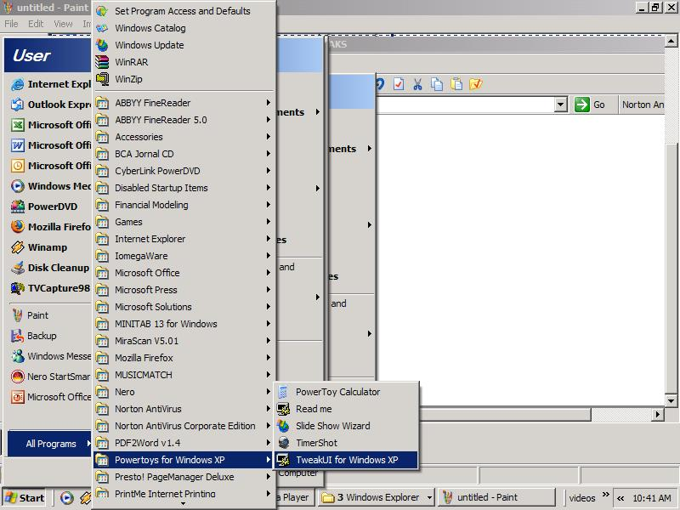

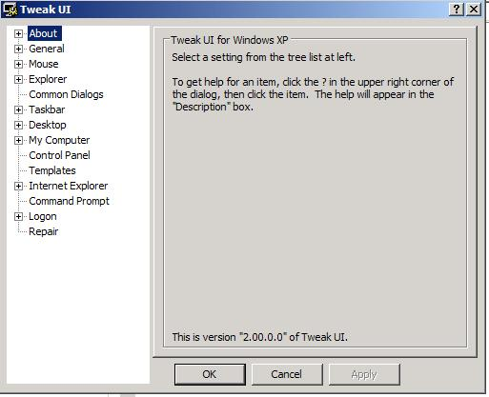

Many a times it may happen that you may have multiple applications for the same function e.g. Internet Explorer 6.0, Mozilla Firefox, Netscape Navigator all these are internet browsers but only one can be set as default, once chosen you may or may not know how to undo the same. It is actually far more simpler than you imagined, how??? See picture below

